**Project Documentation**

**Project Title: Uncleaned_DS_jobs**

# Project Overview

This project analyses Jobs Market data using Excel and Power BI to find trends and current scenario in the job market. This Project helps to identify job market current scenario of employees Min & max salary ranges, competitors, revenue etc.

# 2. Tools Used

* Microsoft Excel
* Power Query
* Power BI Version: 2025.07 (latest release cycle)

# 3. Dataset

* Source: “C:\Users\user\Desktop\mini project\Datasets\uncleaned_ds_jobs.csv”

Data contains: In the cleaned version the columns explanation are as follows,

* **Job Title**: Title of the job posting.
* **Job Description**: This contains the full description of that job.
* **Salary Min, Salary Max, Salary Average**: Refers to the minimum, maximum and average salary for that post.
* **Rating**: Rating of that post.
* **Company**: Name of company.
* **Location**: Location of the company.
* **Headquarter**: Location of the headquarters.
* **Size**: Total employee in that company.
* **Founded**: year of established
* **Type of ownership**: Describes the company type i.e non-profit/public/private farm etc.
* **Industry, Sector**: Field applicant will work in.
* **Revenue**: Total revenue of the company.
* **Competitors**: comparing with another competitor companies.

# 4. Steps Followed

* Cleaned data in Excel & Power Query (Remove empty rows, Create Calculated Columns, Remove Duplicates, Fix data types, , Split Columns, Merged Columns, Rename columns to clear names, Trim & clean text columns Remove text prefixes, Convert `salary estimation` to proper Min & Max salary ranges, Ensure.
* Used Excel formulas for basic analysis
* Imported cleaned data into Power BI and create DAX for making report.
* Built, dashboards using charts, slicers, and KPIs

# 5. Key Insights

* Card for Average max salary Min Salary, Total Jobs, Salary mid-point company rating.
* Filled Map – Location and Revenue.
* Clustered Column Chart for Average Max salary by Company name.
* Clustered Column Chart for Average Max salary by sector.
* Pie Chart for Average Min Salary by size of Employees.
* Funnel chart for Count of Revenue by sector.
* Line Chart for Average Min salary by sector.
* Gauge chart for Salary Mid-Point.
* Slicers – Size of employees & location.
* Clustered Bar chart for Total jobs by company name.
* Tree Map for Average company rating by competitors.
* Table for comparison about company name, total jobs, Average company rating, average max salary and Min salary.

6. **Screenshots** 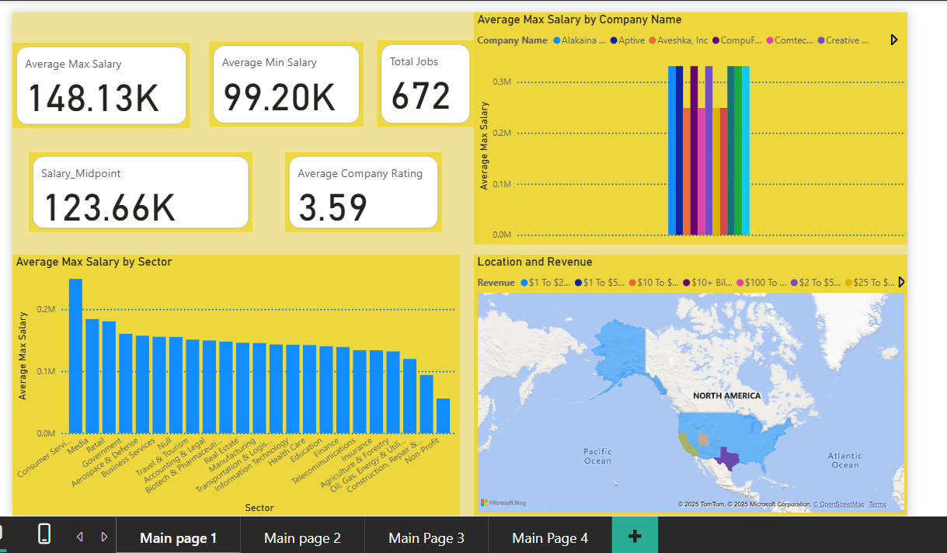

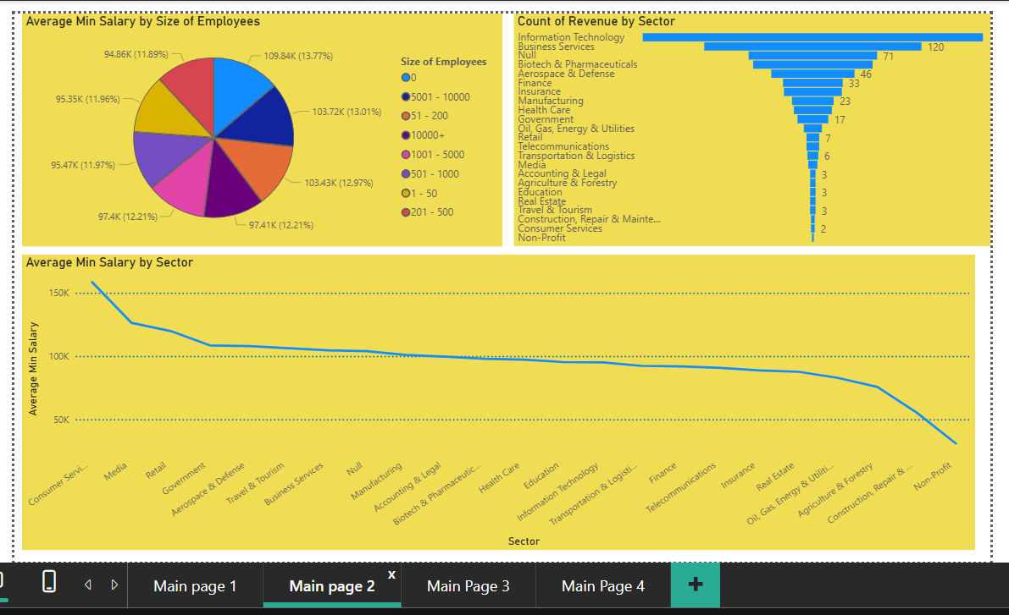

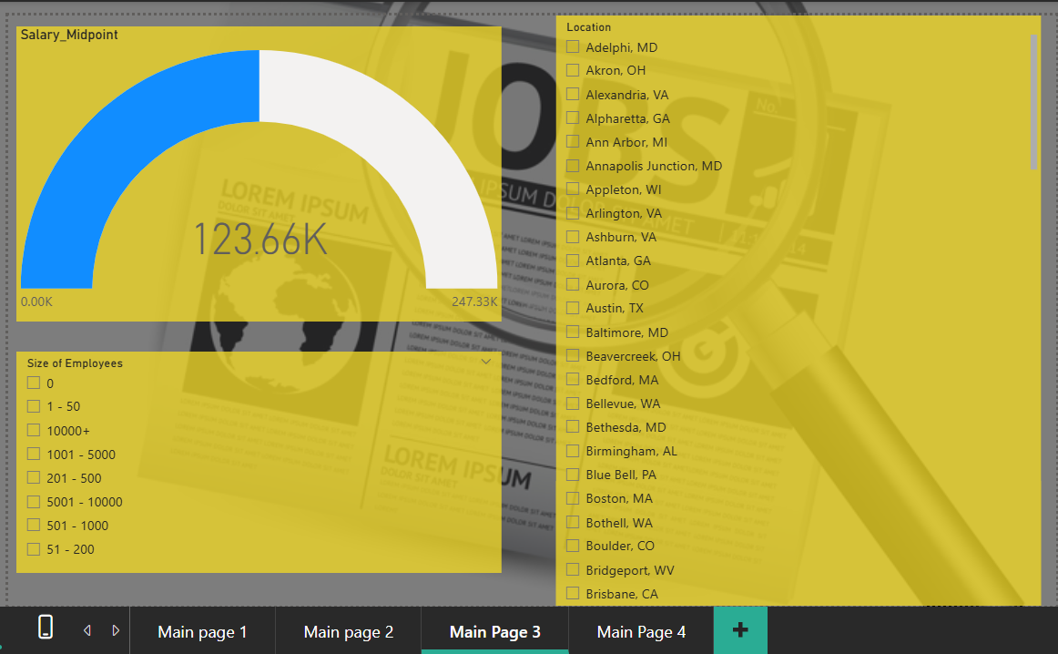

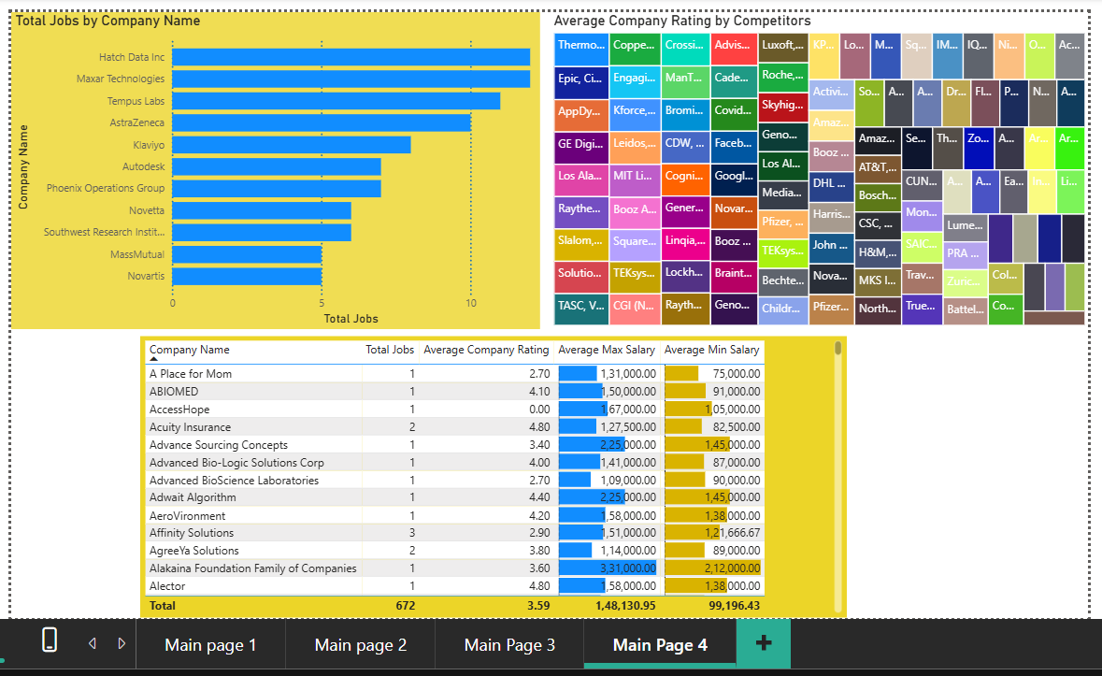

# 7. Files Included

* " C:\Users\user\Desktop\mini project\Datasets\ Uncleaned_DS_jobs.csv" – **Uncleaned data**.
* -" C:\Users\user\Desktop\mini project\\ Arjun_Das_Updated - Uncleaned_DS_jobs.xlsx"– **Cleaned data and basic analysis**
* " C:\Users\user\Desktop\mini project\ Arjun_Das - Uncleaned_DS_jobs work file.pbix"– **Power BI dashboard**
* ‘README.md’ – **Project description**

# 8. How to Use

* Open “Arjun_Das_Updated - Uncleaned_DS_jobs.xlsx” to view the cleaned data.
* Open “Arjun_Das - Uncleaned_DS_jobs work file.pbix” in Power BI Desktop to explore the visuals.